Stamford University Bangladesh

Department of Computer Science & Engineering



A LIBRARY MANAGEMENT SYSTEM

Software Engineering Sessional

Information Gathering

DREAM CRUSHER

Submitted By

#JONY MARTIN CSE 063 07515

#ABU RISHAD CSE 063 07437

#ABIR HOSSIAN CSE 063 07441

Introduction:

After completing the project proposal and project feasibility part successfully, we have decided to move on to the next phase of our project, which is the information gathering and representation with the following objectives in mind.

Objectives:

• Construct meaningful interview questions

• Understanding the client & organization’s view

• Understanding the current system

• Write effective questions to survey users about their work.

• Creating data flow diagram

Information Gathering will be shown by three ways:

1. Interview

2. Questionnaires

3. Investigation

1. Interview Information:

01. Which people could use your library?

▶Mainly students or it can be educated people.

02. Is there any other library should connected to your library?

▶Not Concerned yet.

03. Should it need high privacy and security?

▶We just need a primary security.

04. How can social media be used to enhance library services?

▶Social media allows libraries to target the audience with tailored messages or can use Facebook and Twitter and Instagram

05. What is the biggest challenge now faced in your library?

▶Problems differ from library to library. There are various dimensions and factors associated with it. It depends upon the situation and other reasons.

06. What are the inputs and outputs in an e library system?

Inputs:

▶Book details

▶Borrower details

▶Date & time borrow

Outputs:

▶Date & time borrower can renew the book online

▶Date & time borrower needs to physically return the book for renewal / return

▶Penalty payment to collect from the overdue borrower

2. Questionnaire (Users):

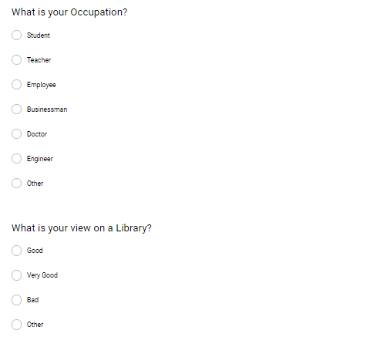

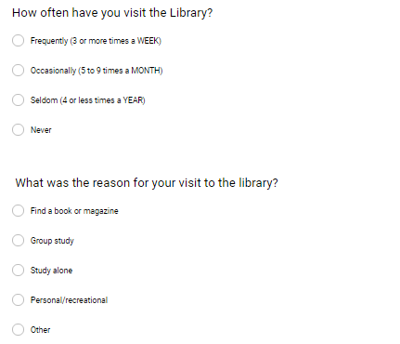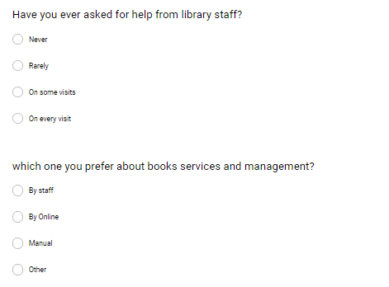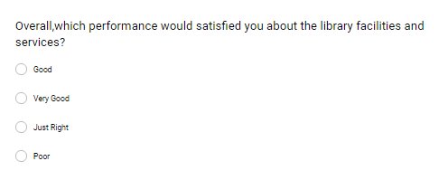

3. Investigation:

* Benefits to be provided by the system
* Gathering Information
* Getting Knowledge of the project request
* Rough estimation of the costing for the system
* Feasibility of development

Summary:

Our project in only a humble venture to satisfy the needs in a library. Several user friendly coding have also adopted. This new system shall prove to be a powerful package in satisfying all the requirements of the organization.

Conclusions:

The Library Management System allows the user to store the book details and the person's details. This System allows storing the details of all the data related to library. The implementation of the system will reduce data entry time and provide readily calculated reports.

Appendix

Results of the questions: 